**Instructions:** In this lab, you will become familiar with basic networking tools, ip and ifconfig, to manage your networking devices on a Linux device. Rarely do we keep our systems isolated from any type of network, so having the skills necessary to manage your network connections is absolutely necessary for any Linux administrator.

For this lab, I simply providing instructions on the tasks I want you to perform. I will not be giving examples of commands. As with previous labs, you will need to provide screenshots of your work with explanations of what each screenshot is showing. My reason for not providing commands is networking is best learned with trial and error.

This is a two-part lab. The first part requires you to perform basic networking commands to change the network settings using both ip and ifconfig tools. The second part requires you to create bonded network adapters on your CentOS VM and explain the different bonding modes available for use.

* Part One (performed on Ubuntu)
  + Use the ip tool to show currently enabled networking devices

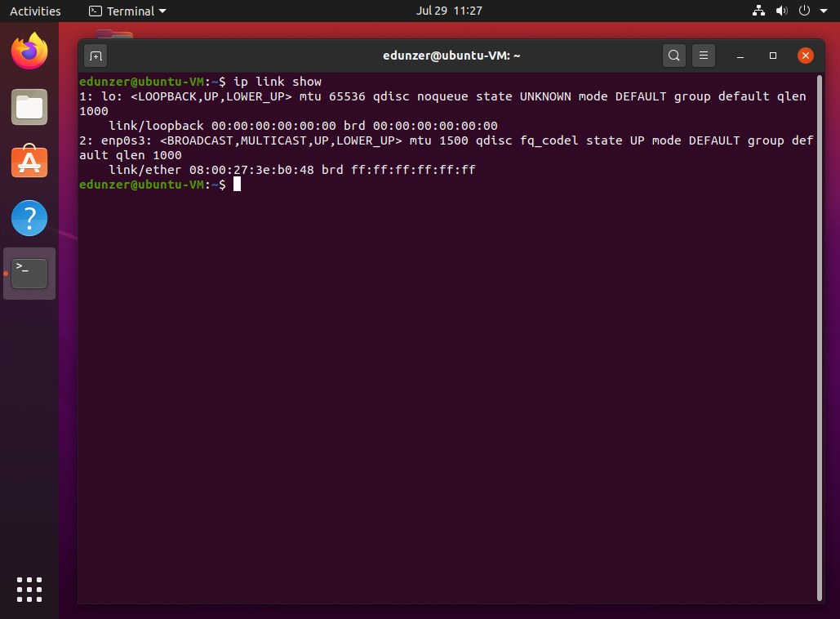

* + Use the ip tool to shutdown your Ethernet adapter

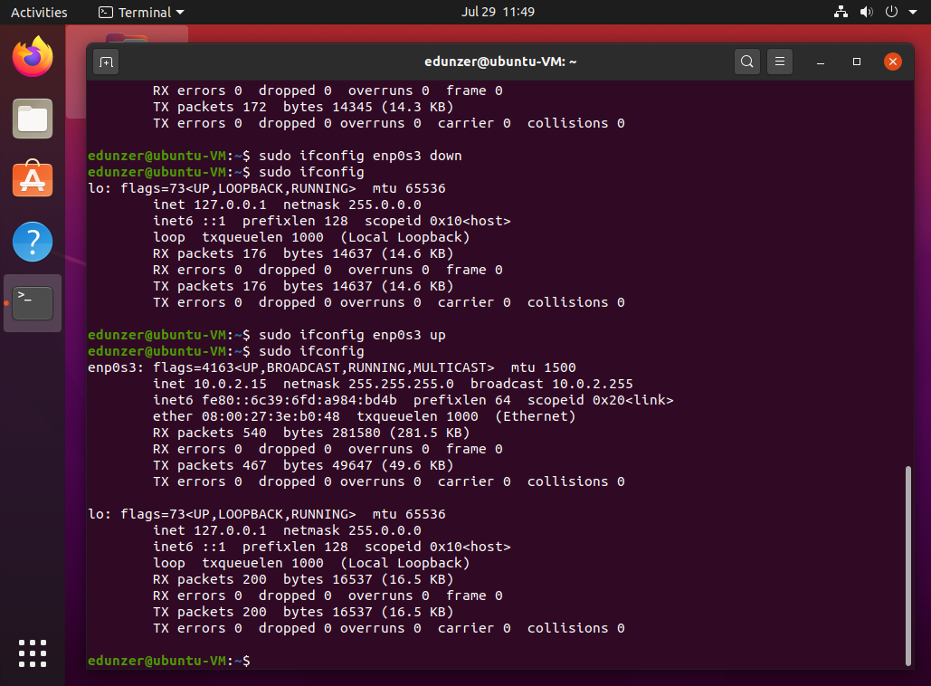

* + Use the ip tool to set your Ethernet adapter address to 192.168.0.10 with a subnet mask of 255.255.255.0

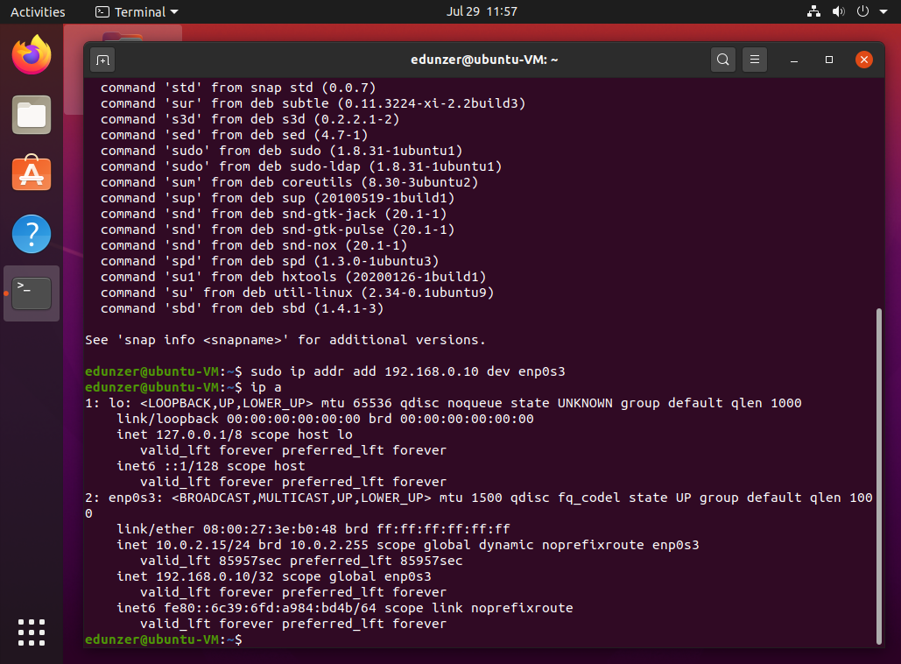

* + Use the ip tool to show your changes
    - Hint: you might need to re-enable your adapter to see the changes
  + Use the ifconfig tool to change your Ethernet adapter address to 10.10.10.5 with a subnet mask of 255.255.255.0

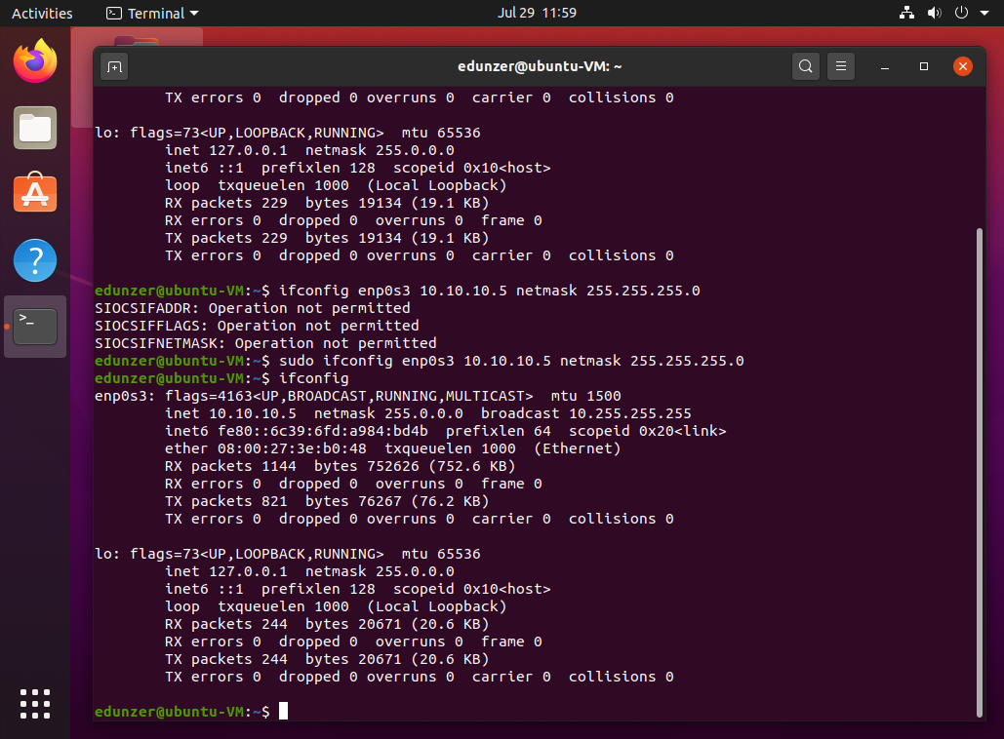

* + - Hint: you might need to install the net-tools package in order to use ifconfig
  + Use the ifconfig tool to shutdown your Ethernet adapter

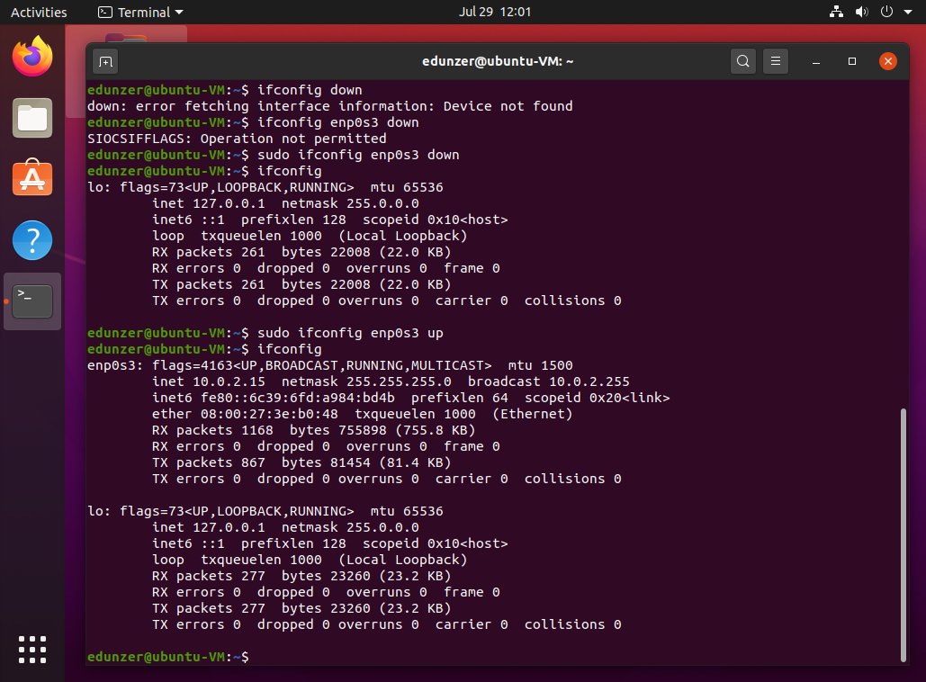

* + Use the dhclient tool to re-enable your Ethernet adapter and automatically grab an IP address from the DHCP server running in VirtualBox.
    - Note: the DHCP server is already running, you do not need to set up the server

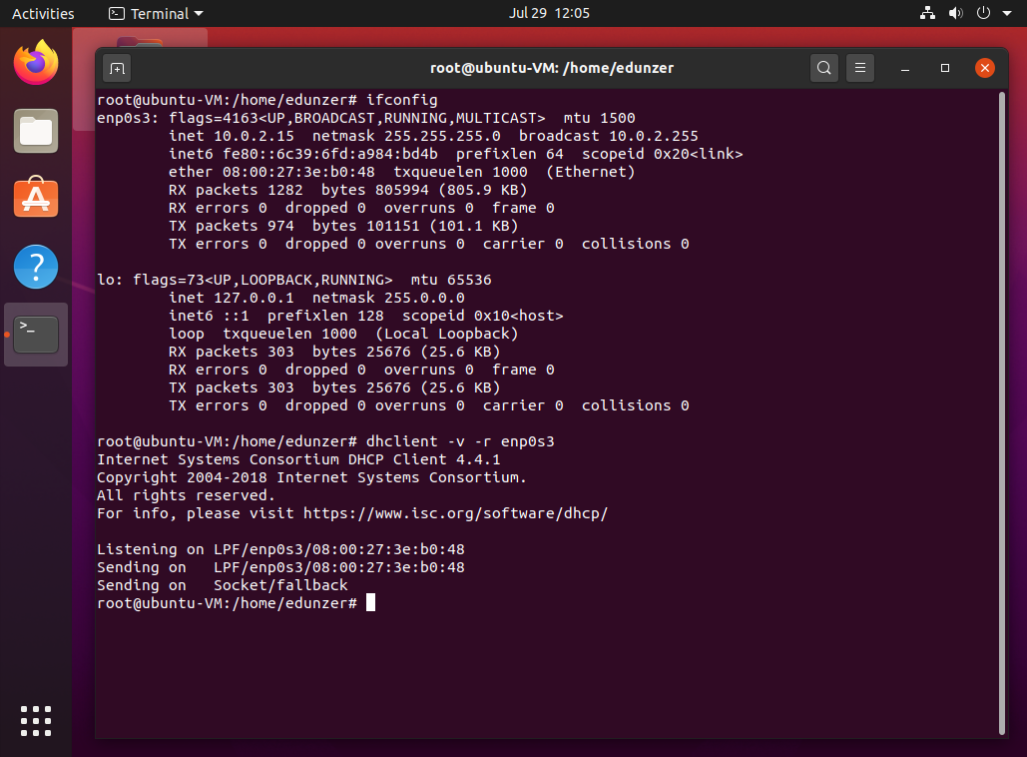

* + Use the tcpdump utility to view current network connections.
    - Open Firefox and monitor your tcpdump window.
    - Explain what you are seeing and why do you see so much traffic just by opening your web browser?

After running the tcpdump command and opening firefox all the packets that are being received or transferred over the network are showing. The reason so many are happening just by opening the browser is because browsers have lots of background processes now days to support all their features.

* Part Two (performed on CentOS)
  + Begin with reviewing Chapter 9 of your textbook to gain an understanding of how Linux offers networking services, where configuration files are located, and what utilities are available to modify network connection settings.
  + In your VirtualBox Manager, edit the Network settings on your CentOS VM.
    - Ensure you have two adapters enabled, and both are set to Host-Only.
  + Research how to configure networking bonding in CentOS 7 and configure your two adapters to use bonding.
  + Once configured, show your ip a output (or ifconfig, whichever you prefer).

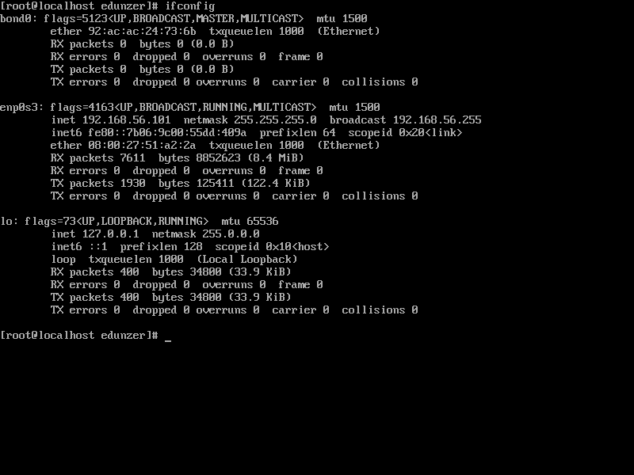

* + - You will need to list your steps taken to configure adapter bonding, be sure to include all details to reach full points.

To create a bond run this command below

nmcli con add type bond con-name bond0 ifname bond0 mode active-backup

* + Conclude this lab by explaining the different bonding modes and provide example scenarios in which each mode could be used.
    - Hint: think enterprise-level networking and server-related services
    - Hint: most of your configurations will be made in the /etc/sysconfig/network-scripts directory

In total there are 6 types of bonds. Most notably different are 1 and 3 which do not have load balancing. Mode 0 allows for packets to be sequentially transmitted/received. Mode 1 is basically a active backup so if one goes down the other becomes active. Mode 3 is basically a duplicate mode where all transmissions are sent on all slaves.

* Save and upload to Canvas for grading.